Lab 1:

Installing Linux  
virtual machines   
using VMware

Linux Server Security  
 2024-2025

© Daan Pareit

## Introduction

# Lab concept

During this lab, we will create our first Linux servers, one Debian and one Red Hat Enterprise Linux (RHEL), as Virtual Machines (VM), which we’ll use throughout the course. You’ll create the environment as shown below.



# Learning goals

* Using/installing VMware Workstation/Fusion Pro
* Using/installing Debian Linux
* Using/installing Red Hat Enterprise Linux (RHEL)

# Practicalities and prerequisites

You’ll need the following:

* A laptop/desktop 😊
* At least about 11 GB of free disk space
  + +/- 2 GB for downloaded files (600 MB VMware, 900 MB RHEL, 600 MB Debian)
  + +/- 1 GB for VMware installation
  + +/- 5 GB for fresh installed linux VMs (3 GB Debian, 2 GB RHEL)
  + +/- 3 GB which will be claimed to offload VM’s virtual memory when running these
* We will use VMware to work with Virtual Machines. You need to install VMware Workstation Pro (on Windows) or VMware Fusion (on Mac). See further in this document.
* Download the ISO file of Debian to a folder on your laptop.   
  We need the **debian-12.7.0-amd64-netinst.iso** file, which is available here:   
  <https://cdimage.debian.org/debian-cd/current/amd64/iso-cd/>
* A Red Hat developer account
  + Red Hat Enterprise Linux is not free, but it is open source. This means it is legal to download and develop the operating system, but not legal to use it in production without a (paid) subscription.
  + However, developer licenses are free. You’ll also have to obtain such a free developer license:
    - Open <https://developers.redhat.com> and **Create a Red Hat account**, remember your username and password, as it is needed during the installation.
    - Verify your account via the confirmation e-mail. Note: when using your @student.howest.be e-mail address; you’ll probably find the confirmation mail in your spam folder 😊.
    - Finally, surf to <https://www.redhat.com/wapps/sso/login.html> to complete your registration: choose a subscription that matches ‘personal’ or “Red Hat Developer” and complete the required information.
    - It could take a while (> 15 min, less than 12 hours) before your developer subscription is linked to your account. Verify you have an active subscription at <https://console.redhat.com/subscriptions/inventory>
* Download the ‘Boot ISO’-file of Red Hat Enterprise Linux to a folder on your laptop.   
  We need the **rhel-9.4-x86_64-boot.iso** file which is available here:   
  <https://developers.redhat.com/products/rhel/download/>

## Installing VMware virtualization software

We will use VMware to work with Virtual Machines. You need to install:

* VMware Workstation Pro (on Windows)
* or VMware Fusion Pro (on Mac).

Since mid-2024, Broadcom (which acquired VMware in 2023) has been offering this software for free.

First you need to register at: <https://profile.broadcom.com/web/registration>

Next, you can download the software for personal usage:

* Workstation Pro (Windows/Linux): <https://support.broadcom.com/group/ecx/productdownloads?subfamily=VMware+Workstation+Pro>
  + Note for Windows users: version 17.6.0 has a bug causing it only to run on Windows editions which have English as system language. In that case, install version 17.5.2.
* Fusion Pro (Mac): <https://support.broadcom.com/group/ecx/productdownloads?subfamily=VMware%20Fusion>

## Installing Debian linux

1. In VMware Workstation click on the menu item “**New Virtual Machine**” to create a new virtual machine (VM). The wizard will help you with this.

* Choose for ***Typical installation***
* Choose ***I will install the operating system later***
* Choose for ***Linux*** as OS and choose for **“Debian 12.x 64-bit**”
* Enter a name for your VM (e.g. ***Debian***)
* Choose a **hard disk of 20 GB** (default) and choose to save the virtual disk **as a single file**
* Click on the **Finish** button

1. Connect your downloaded Debian ISO file to the CD/DVD of your VM in VMware Workstation. You can do that via the settings menu of your VM.

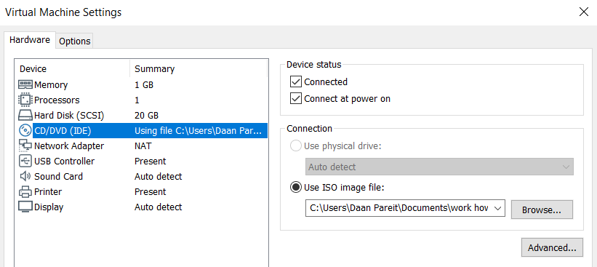

1. Power on your Debian-VM
2. Select the **second** option (**Install**). Don’t go for the graphical install, it has limited added value.

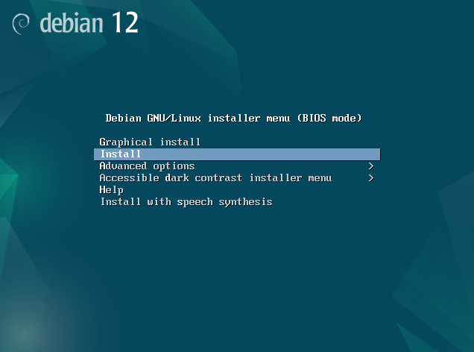

1. Choose ***English*** as language.
2. Choose ***other-Europe-Belgium*** as country.
3. Choose ***United States*** as default locale setting.
4. Choose ***Belgian*** as keyboard (for your AZERTY keyboard or ‘American English’ for QWERTY).
5. Choose ***debian-<firstname>-<lastname>*** as hostname.   
   **This is important to verify your individual assignments later**! **Labs will be zero graded without personalized prompts.**
6. Choose ***localdomain*** as domain name or leave this empty.
7. Enter a password for the root account. Attention: press the NumLock if you want to use ciphers!
8. Enter ***your first name and last name*** as full name for the new user.
9. Enter ***your*** **first name** as username for your account.
10. Enter a ***password for your account***.
11. Choose ‘***Guided - use entire disk’*** (default setting) as partitioning method.
12. Choose the proposed disk (sda) to partition.
13. Choose ***All files in one partition*** as partitioning scheme.
14. Choose Finish partitioning and write changes to disk.
15. Choose *<****Yes****>* to write the changes to disk.
16. Choose ***<No>*** for extra installation media.
17. Choose ***Belgium*** as a Debian archive mirror country.
18. Choose ***deb.debian.org*** as Debian archive mirror.
19. Choose ***Continue*** to indicate that you do not use a http proxy.
20. Choose *<****No****>* to indicate that you don’t want to participate in the package usage survey.
21. Select ONLY the ***standard system utilities*** and ***SSH server*** in the software menu by pressing space bar (and thus **unselect** the “**Debian desktop environment**”and “**GNOME”** by pressing the space bar)

1. Choose *<****Yes****>* to install the GRUB boot loader to the primary drive.
2. Choose ***/dev/sda*** as device for boot loader installation.
3. Choose “***Continue***” to complete the installation.
4. After a while, Debian will start up and show you the login prompt. Check that you can sign in with the root credentials and with your own credentials.

## Give your Debian just a little extra…

Now we have a cleanly installed Debian, there are just a few additional convenient packages you’ll want to install. Contrary to RHEL, the sudo package is e.g. not installed by default.

1. Always logging in as root is NOT good practice. Therefore, you’ll have to install the **sudo** package for elevated permissions for regular users only when needed. To install the package, using “apt install sudo” you’ll need to login or switch to root once (eg su --login).

Log in as root, or as the user and then do **su --login**

1. Now, add your regular user to the ‘sudo’ group using “usermod -aG sudo *<loginname>*”. Then logout from the root shell as you’ll be able to work with the sudo command as a regular user from now on. If you’re back in your user shell, note that you might also need to logoff and log on again with your regular user for its sudo group membership to be taken into account.

After installing sudo, run **usermod -aG sudo serafim**, then **exit** and enter the credentials for **serafim**

and run **groups** to check

Good moment to create a snapshot

Other packages with are recommend adding to your clean Debian (using “sudo apt install <packagename>” are these:

* **openssh-server**: to install the SSH server in case you forgot to tick this option during installation. Working over SSH is recommended and much more comfortable compared to working at the console view within your VMware software.
* **open-vm-tools**: this allows better interaction between your Debian and VMware. Your VMware software will now know about Debian’s IP address which makes it e.g. possible to right click your VM and make it connect to your Debian over SSH (without manually finding out its IP address). Cfr <https://kb.vmware.com/s/article/340> for more information. This package might also already have been installed by default.
* **tcpdump**: this is a network tool for capturing incoming/outgoing packets on an interface. It’s like Wireshark on cli.

sudo apt update

sudo apt upgrade

sudo apt install openssh-server open-vm-tools tcpdump

## Installing Red Hat Enterprise Linux (RHEL)

1. In VMware Workstation click on the menu item “**New Virtual Machine**” to create a new virtual machine (VM). The wizard will help you with this.

* Choose for ***Typical installation***
* Choose ***I will install the operating system later***
* Choose for ***Linux*** as OS and choose for **“Red Hat Enterprise Linux 9 64-bit**”
* Enter a name for your VM (e.g. ***RHEL***)
* Choose a **hard disk of 20 GB** (default) and choose to save the virtual disk **as a single file**.
* Click on the **Finish** button

1. Connect your downloaded RHEL ISO file to the CD/DVD of your VM in VMware Workstation. You can do that via the settings menu of your VM.



1. Power on your RHEL VM
2. Select the first option (**Install Red Hat Enterprise Linux 9.x**).

1. Choose ***English (United States)*** as language and continue.
2. You’ll see the graphical ‘Installation summary’ in which you’ll have to complete different items in the next steps.

If it lags - disable 3D acceleration

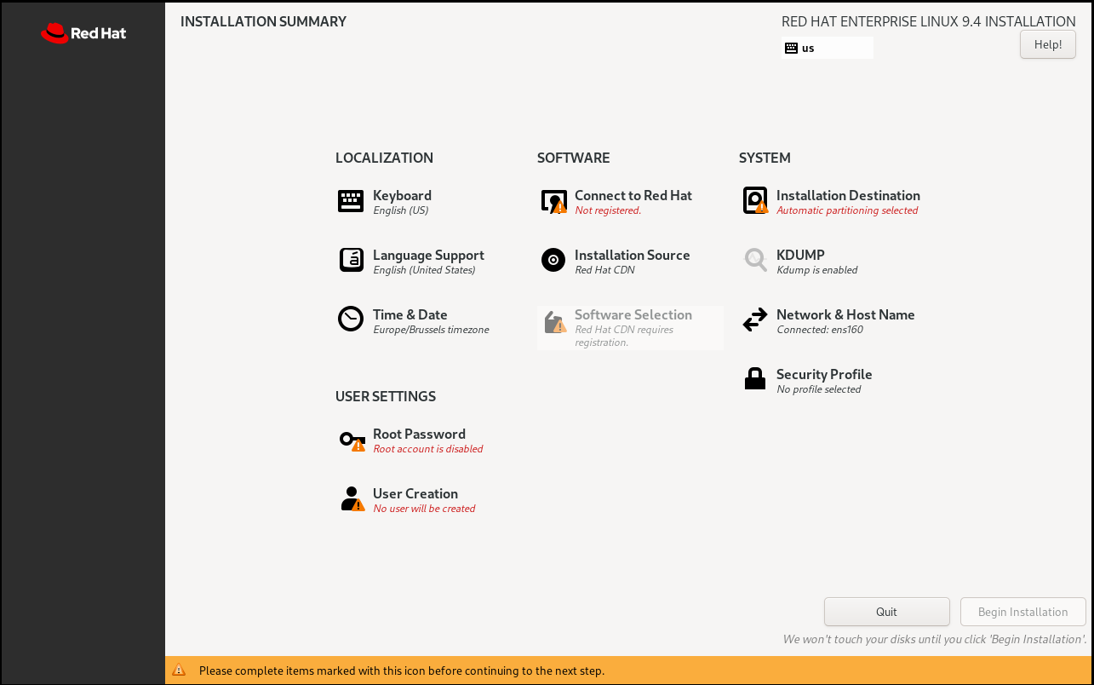

1. ***Keyboard*** 
   1. When using AZERTY keyboard, change the ***Keyboard*** by adding the **French (Belgian)** keyboard and removing the **English (US)** keyboard.
2. Click on ***Connect to Red Hat*** and enter the credentials of your free Red Hat Developers account (see earlier ‘Practicalities and prerequisites’ section of this document). Click on ‘Register’.   
   If successful, you should read ‘The system is registered’ on top and ‘1 subscription attached to the system’ at the bottom.
   1. In case of authentication failure:
      1. Verify your password by typing it in the username field, to detect a possible wrong keyboard layout.
      2. Verify you have a developer subscription linked to your account at <https://console.redhat.com/subscriptions/inventory>
      3. Still no luck? You still need a valid developer subscription as described above, but try this alternative method instead:
         1. Download the ‘DVD iso’ (10 GB) instead of the ‘Boot iso’ (1 GB) from <https://developers.redhat.com/products/rhel/download> . Note: you’ll have to scroll way down to the ‘All Downloads’ section. Make sure you download the ‘rhel-9.4-x86_64-dvd.iso’ file.
         2. In the CD/DVD settings menu of your VM in VMware Workstation, change to this iso file and reboot the VM. Follow the previous steps again but skip the ‘Connect to Red Hat’ section for now. You’ll have to activate it after installing.
         3. Continue with the next steps
3. ***Network & Host Name***
4. Switch the Ethernet button to **“on”** (should be ok by default)
5. Change hostname to **rhel-<firstname>-<lastname>** and click ***Apply*** and then ***Done*This is important to verify your individual assignments later! Labs will be zero graded without personalized prompts.**
6. ***Time & Date***
7. Choose ***Europe-Brussels***, set the time manually or enable ‘Network Time’ (should be ok by default) and click ***Done***
8. ***Installation Destination***
9. Accept the proposed automatic partitioning option by clicking ***Done***
10. Set a **Root Password** (you might need to scroll down)
11. To work in a proper way, also **create a regular user account** and check the box to make it an ‘administrator’ (which will give it sudo permissions).
12. In case of ‘greyed out’ fields: enable the Ethernet button first, see a few bullet items above.
13. Select *Software Selection* and select “**Minimal Install**” without any additional software selected
14. Click ***Begin installation***
15. Click reboot when finished
16. After a while, RHEL will start up and show you the login prompt. Check that you can sign in with the root credentials and with your own credentials
17. If you’ve installed RHEL using the ‘DVD iso’ instead of the ‘Boot iso’ due to registration issues during installation, you now still need to activate your RHEL:
    1. Go to <https://console.redhat.com/insights/connector/activation-keys>
    2. Below the ‘Activation Keys’ title, you read an ‘Organization ID’. Take note of this number, you’ll need it in a minute.
    3. Now, create an activation key
       1. Choose a name and remember that one, you’ll need it as well.
       2. Select ‘Latest release’ as workload
       3. As System Purpose, select ‘RHEL Server’ role, ‘Self Support’ Service Level and ‘Development/Test’ usage
    4. Now, in your RHEL, as root user, execute following commands:
       1. subscription-manager register --activationkey=<your key name> --org=<your organization number>
       2. subscription-manager attach --auto
       3. subscription-manager status
    5. This suffices for activation. However, if you also want your RHEL to be connected to ‘Red Hat Insights’ for remote monitoring through their web interface, than you can also optionally run the following command:
       1. insight-client --register

## Give your RHEL also a tad more…

To work in a proper way, also **create a** **regular user account**. If you were not able to create one during installation, you can still do so right now. Go the official documentation for RHEL 9: <https://docs.redhat.com/en/documentation/red_hat_enterprise_linux/9/html/configuring_basic_system_settings/index> . Navigate to the chapter about ‘Managing users and groups’ and use the commands listed there to 1/ create a new user, 2/ provide it with a password and 3/ put it in the ‘wheel’ group. Note that RHEL uses a ‘wheel’ group rather than a ‘sudo’ group for users which are granted to execute the ‘sudo’ command.

Now that we also have a cleanly installed RHEL, there are just a few additional convenient packages you’ll want to install.

In RHEL, the OpenSSH server is installed and running by default. Working over SSH is recommended and much more comfortable compared to working at the console view within your VMware software.

Other packages with are recommend to add to your clean RHEL (using “sudo dnf install <packagename>” are these:

* **open-vm-tools**: this allows better interaction between your RHEL and VMware. Your VMware software will now know about RHEL’s IP address which makes it e.g. possible to right click your VM and make it connect to your RHEL over SSH (without manually finding out its IP address). Cfr <https://kb.vmware.com/s/article/340> for more information. This package might have been installed by default.
* **tcpdump**: this is network tool for capturing incoming/outgoing packet on an interface. It’s like Wireshark on cli.

sudo dnf install open-vm-tools tcpdump

## Backup

Now that you have your Debian and RHEL ready, it’s a good time to take a backup of both when you would want to go back to clean machine if ever necessary. A few options to do so:

* take a snapshot in VMware (right click your VM), preferably when the VM is powered off
* export your VM to an OVA file via VMware’s main menu or (when powered off)
* copy your VM folder in Windows/Mac explorer to a backup location (preferably when powered off)

Hint: to shut down your VM properly, use the following command: sudo poweroff (which makes sense, doesn’t it 😊 )